WAN MOHAMMAD FAISAL BIN SAMMIO (B031720043)

Soliseheaswar Sridaran (B031720019)

Cryptography with Python

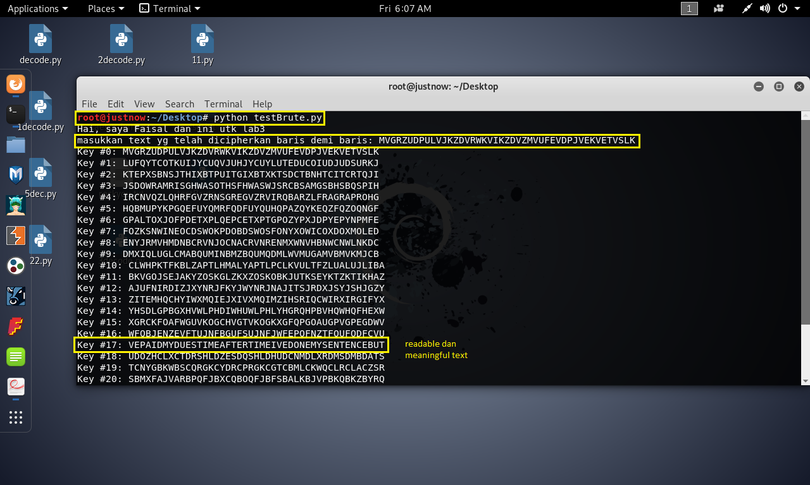PLAIN TEXT : VE PAID MY DUES TIME AFTER TIME I VE DONE MY SENTENCE BUT COMMITTED NO CRIME AND BAD MISTAKES I VE MADE A FEW I VE HAD MY SHARE OF SAND KICKED IN MY FACE BUT I VE COME THROUGH WE ARE THE CHAMPIONS MY FRIENDS AND WELL KEEP ON FIGHTING TIL THE END WE ARE THE CHAMPIONS WE ARE THE CHAMPIONS NO TIME FOR LOSERS CAUSE WE ARE THE CHAMPIONS OF THE WORLD I VE TAKEN MY BOWS AND MY CURTAIN CALLS YOU BROUGHT ME F AME AND FORTUNE AND EVERYTHING THAT GOES WITH IT I THANK YOU ALL BUT ITS BEEN NO BED OF ROSES NO PLEASURE CRUISE I CONSIDER IT A CHALLENGE BEFORE THE WHOLE HUMAN RACE AND I AINT GONNA LOSE WE ARE THE CHAMPIONS MY FRIENDS AND WELL